
Mathematics Specialist
Test 3 2016

Vectors in 3D

NAME: _______________________________________________ TEACHER: MLA

45 marks 45 minutes

One unfolded A4 page of notes, SCSA formulae booklet and ClassPad calculator permitted
Question 1 [2 marks]
Use the diagram below to determine the (exact) distance from C to D:

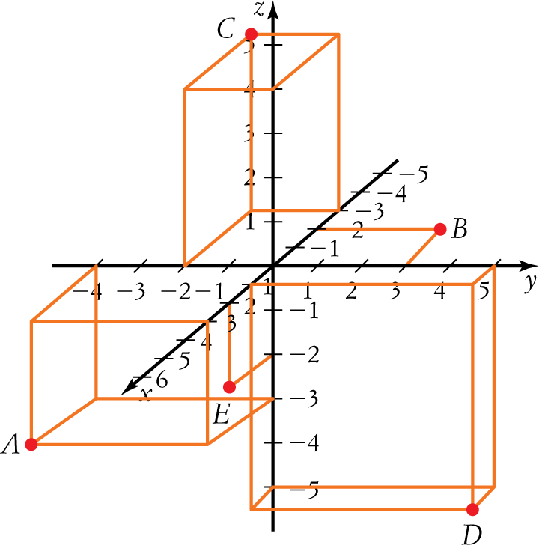

Question 2 [1, 1 & 1 = 3 marks]
Vector u has norm 8, and both azimuthal (in the x-y plane) and altitude angles of 60$°$.
Vector $v=2i-j+4k$
(a) State the (exact) rectangular form for u

(b) Find the acute angle between u and v, correct to two decimal places.

(c) Determine the (exact) vector orthogonal to both u and v

Question 3 [4 marks]

Find the projection of a = (−4, 2, −3) on b = (2, −5, 1)

Question 4 [4 marks]
C is the midpoint of the line segment AB. D is a point not on the line AB such that$DC=CA$.
Use vector methods to prove that DA is perpendicular to DB.

Question 5 [4 marks]
Find the angle between the line $r=\left[\begin{aligned}1-2λ \\ λ \\ 2+3λ\end{aligned}\right]$and the plane $r$ . $\left[\begin{aligned}3 \\ 1 \\ 2\end{aligned}\right]=-4$

Question 6 [5 marks]
Find the equation of the plane containing the points E (4, −3, 1), F (5, 0, 2) and G (3, 2, 5)

Question 7 [4 & 1 = 5 marks]
(a) Determine the vector equation of the plane consisting of all points that are equidistant from the points P (−1, 2, −3) and Q (4, −2, 2).
(b) Hence, or otherwise, state the Cartesian form of the plane in (a)

Question 8 [5 & 2 = 7 marks]
Use elementary row operations to reduce the following system of equations to echelon form:
$$x+y+\left(k-3\right)z=1$$
$$2x+4y+4z=3$$
$$-x+y+\left(7-2k\right)z=m$$

(a) State the values of k and m if the system is to have:
(i) A unique solution
(ii) Infinite solutions
(iii) No solutions

(b) In the case of infinite solutions, find the particular solution for which$x=1$.

Question 9 [6 marks]
The schematic diagram below shows the volume of passengers (in tens of thousands) through airports A, B, C, D, E, F and G in the month of January.
Use Gaussian elimination to find the values of x, y and z if there are 10 000 less arrivals than departures at C, an equal number of arrivals and departures at D, and 20 000 more departures than arrivals at E.

Question 10 [5 marks]
$At time t=0$, the position (r) and velocity (v) vectors of a British warship (B) and German submarine (G) are as follows:

$r_{B}=\left[\begin{aligned}1150 \\ 827 \\ 0\end{aligned}\right]m ; v_{B}=\left[\begin{aligned}10 \\ -2 \\ 0\end{aligned}\right]m/sec$ $r_{G}=\left[\begin{aligned}1345 \\ 970 \\ 0\end{aligned}\right]m ; v_{G}=\left[\begin{aligned}-5 \\ -13 \\ -4\end{aligned}\right]m/sec$

If both vessels maintain their respective velocities, determine the time at which the submarine is directly beneath the warship, and the depth of the submarine at this instant.
Note. The x-y plane represents the surface of the ocean

End of Test 3

